Linux Basic assignment

1. Creating and Renaming Files/Directories Create a directory named test_dir using mkdir. Inside test_dir, create an empty file called example.txt. Rename example.txt to renamed_example.txt using mv

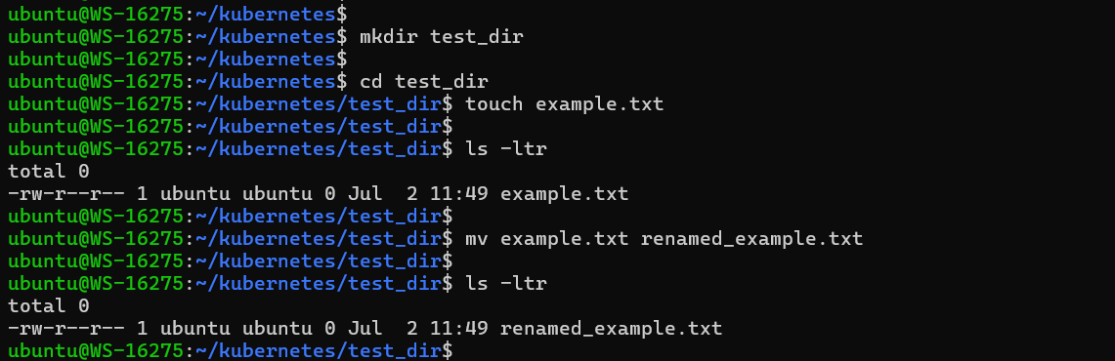

2. Viewing File Contents Use cat to display the contents of /etc/passwd.

Display only the first 5 lines of /etc/passwd using head.Display only the last 5 lines of /etc/passwd using tail.

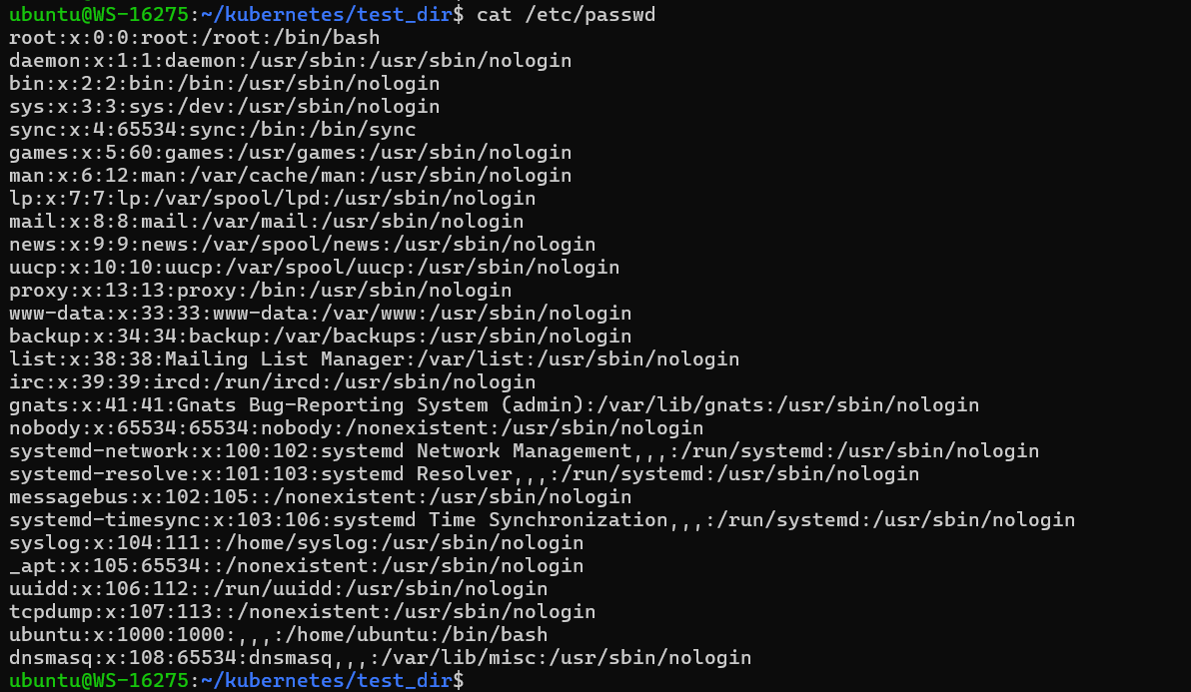

The first 5 lines of /etc/passwd using head.Display

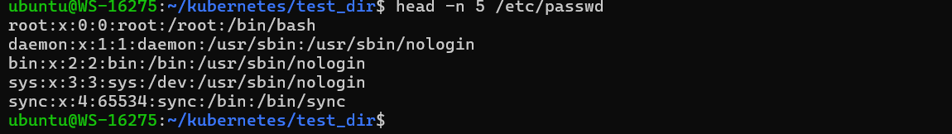

The last 5 lines of /etc/passwd using tail.

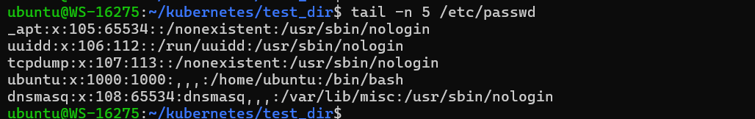

3. Searching for Patterns Use grep to find all lines containing the word "root" in /etc/passwd.

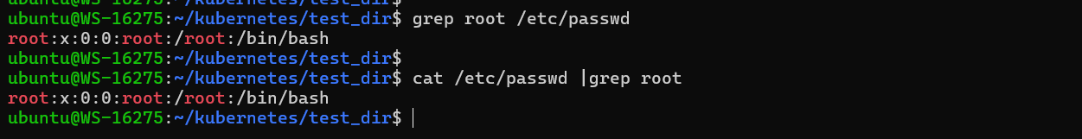

4. Zipping and Unzipping Compress the test_dir directory into a file named test_dir.zip using zip. Unzip test_dir.zip into a new directory named unzipped_dir.

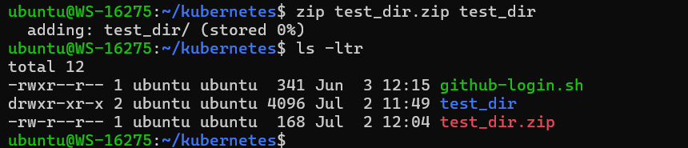

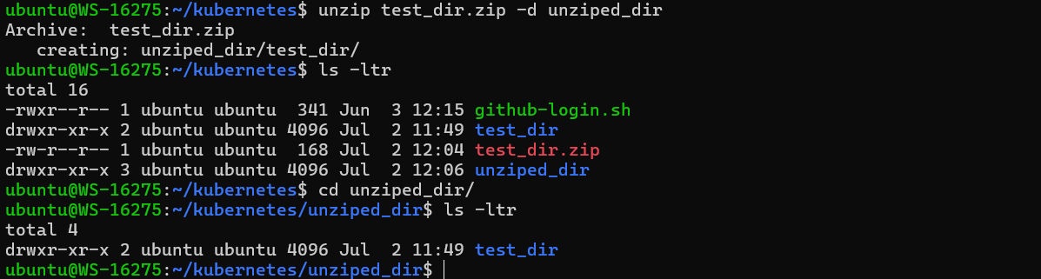

5. Downloading Files Use wget to download a file from a URL (e.g., <https://example.com/sample.txt>).

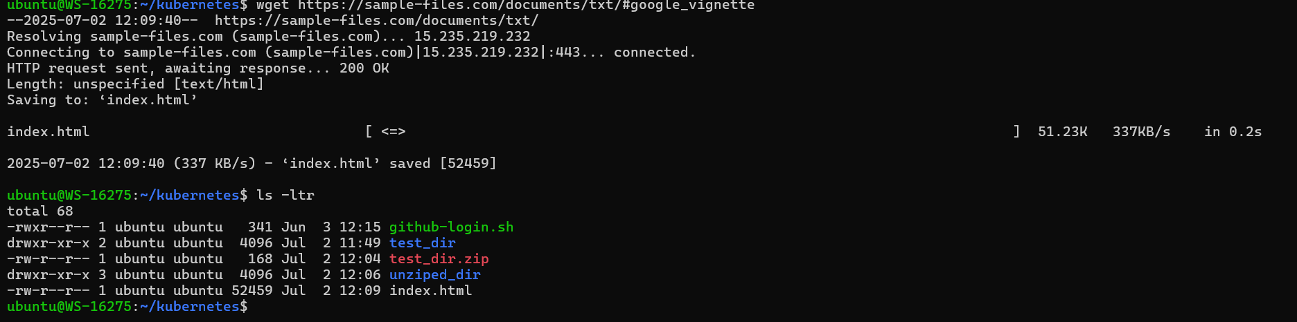

6. Changing Permissions

Create a file named secure.txt and change its permissions to read-only for everyone using chmod.

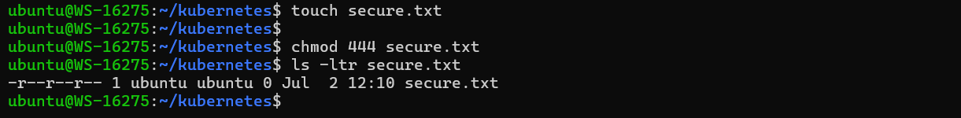

7. Working with Environment Variables

Use export to set a new environment variable called MY_VAR with the value "Hello, Linux!".

